Document 2 : HTML with CSS

Enhancing a web page using advanced HTML and CSS

Prepared by : Mathuppriya Naguleswaran

There are 3 ways to apply CSS
- Inline CSS : CSS written directly inside an HTML tag using style=""
- applying styles directly inside an HTML element using the style attribute.
- Only for very small changes or learning.
- it only affects one specific element.
- this method is not recommended for large projects (it makes HTML messy, repeats code, and is difficult to maintain.)
- Inline CSS uses the style attribute.
- Multiple CSS properties can be written inside one style attribute.
- Inline CSS applies only to the specific element.
- Inline CSS is useful when:
• Styling a single element
• Demonstrating quick changes
<head>
<style>
h1 {
color: blue;
}
</style>
</head>

• Learning how CSS properties work
<h1 style="color: blue; text-align: center;">Travel Adventures</h1>

- Embedded CSS : CSS written inside <style> in the <head> section
- CSS written inside a <style> tag within the HTML file.
- it styles multiple elements in one place and keeps code cleaner.
- It is okay for one page. useful for one page. one HTML page only
- Keeps CSS separate from individual HTML elements (unlike inline CSS)
- Makes it easy to style multiple elements consistently on the same page.
- How to use Embedded CSS?
- Place a section of your HTML.
- Write CSS rules inside the
- Target HTML elements by tag name, class, or ID

- External CSS : CSS written in a separate .css file and linked to HTML
best for clean, reusable, maintainable design. keeps HTML and design separate.
Why use External CSS?
  - One CSS file can style multiple HTML pages
  - Keeps HTML files clean and organized
<head>
<link rel="stylesheet" href="style.css">
</head>
  - Makes future style changes easier
Output of the page.
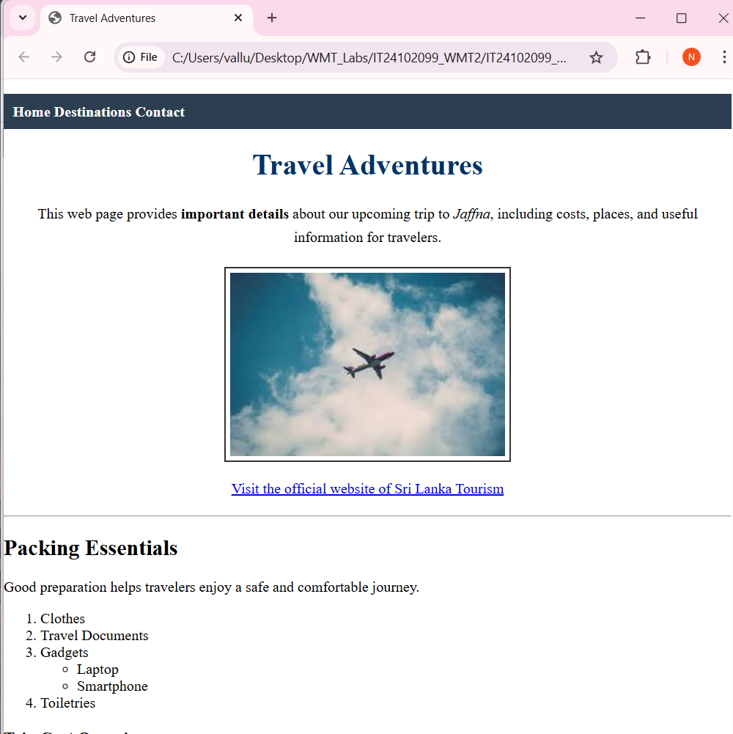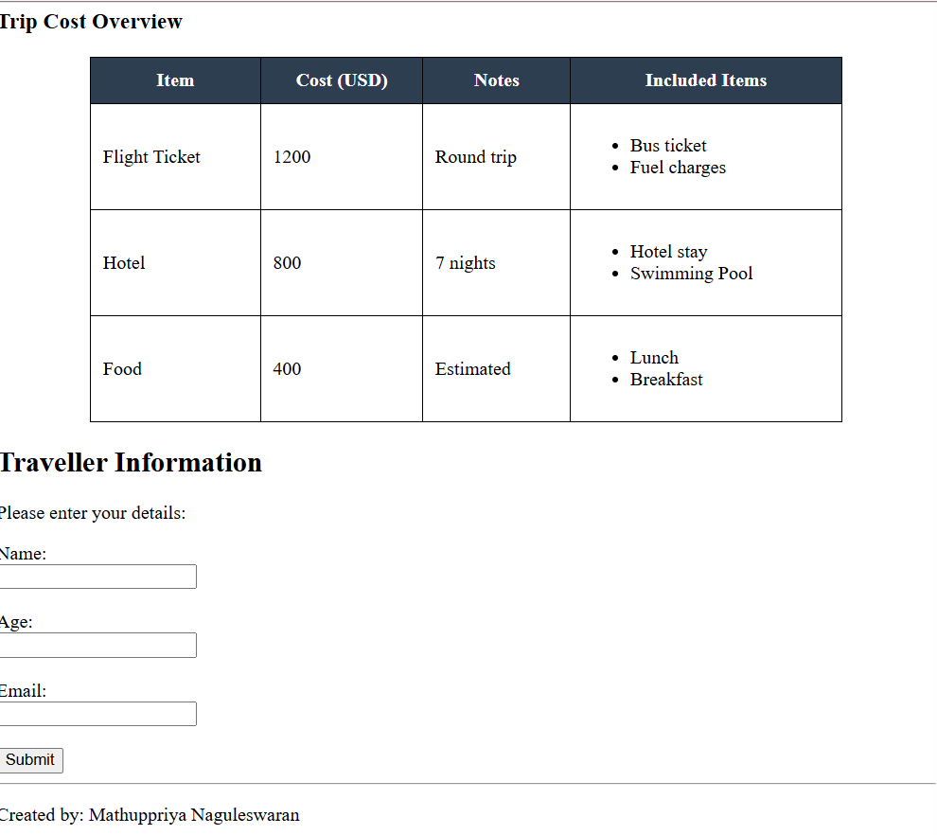
Using Inline CSS
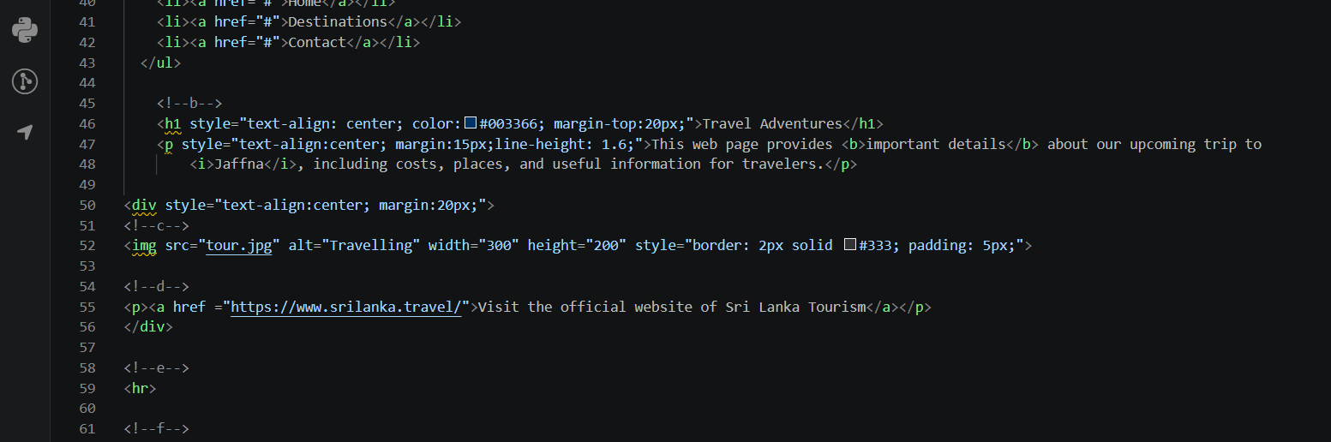
Heading
- <h1> creates the main heading.
- style="" means we are using inline CSS.
- text-align: center; puts the heading in the center.
- color: darkblue; changes the text color.
Paragraph
- <p> creates a paragraph.
- text-align: center; centers the paragraph text.
- margin: 20px; adds space outside the paragraph so it does not look crowded.
Div
- <div> is a container.
- Here it wraps the image and the link.
- text-align: center; centers everything inside it.
- margin: 20px; adds spacing around the whole section.
Image
- src tells where the image file is.
- alt is alternate text shown if the image cannot load.
- width and height control image size.
- border: 2px solid #333; adds a dark border.
- padding: 5px; adds inner space between the image and border.
Hyperlink
<div style="text-align: center; margin: 20px;">
Don’t forget to add semicolons inside style=""
- <a> creates a link.
- href stores the destination URL.

margin is space outside the element.
padding is space inside the element.

Navigation Bar using Lists
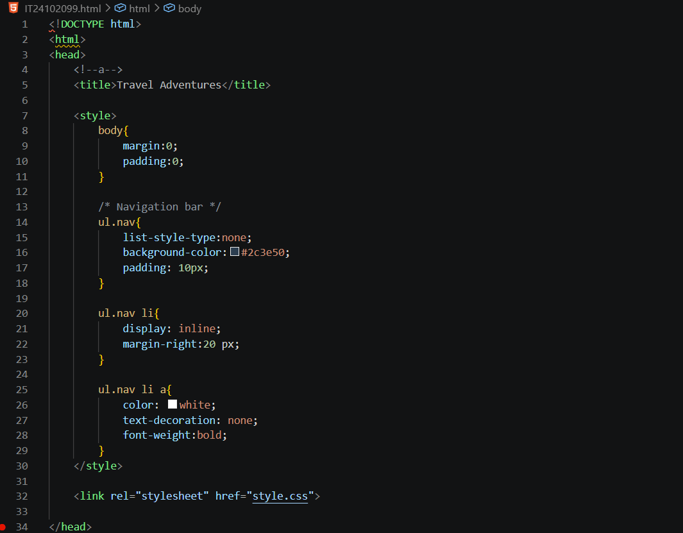

<style> = Embedded CSS starts here
- This means CSS is written inside the HTML file, in the head section.
Body styling
body {
margin: 0;
padding: 0;
font-family: Arial, sans-serif;
}
- removes default browser space
- changes font for better appearance

Navigation bar container
- ul.nav = select the <ul> with class nav
ul.nav {
list-style-type: none;
background-color: #2c3e50;
padding: 10px;
margin: 0;
}
- list-style-type: none; removes bullet points
- background-color gives color to the bar
- padding adds inner spacing
- margin: 0; removes outside spacing

Navigation items
- li are list items
ul.nav li {
display: inline;
margin-right: 20px;
}
- display: inline; makes them appear in one row
- margin-right: 20px; adds gap between items

Navigation links
ul.nav li a {
color: white;
text-decoration: none;
font-weight: bold;
}

- makes links white
- removes underline
- makes text bold

HTML navigation
<ul class="nav">
<li><a href="#">Home</a></li>
<li><a href="#">Destinations</a></li>
<li><a href="#">Contact</a></li>
</ul>
- <ul> creates unordered list
- class="nav" connects it with CSS rule ul.nav
- each <li> is one menu item
- each <a> is the clickable link

navigation is a list of links, and <ul> gives proper HTML structure.
list-style-type: none; It removes the bullet points from list items.
display: inline; To make the list items appear side by side instead of vertically.
the dot in .nav when using class selector
Create Navigation Bar using Lists
1. Create an unordered list (<ul>) to represent a navigation bar.
2. Add at least three navigation links such as: • Home • Destinations • Contact
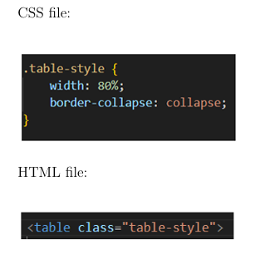
3. Style the navigation bar using embedded CSS to:
- Remove bullet points
- Display items horizontally
- Add background color and spacing.

How are CSS class names declared?
• Class names are defined in the CSS file using a dot (.) before the name.
• The same class name is then used in the HTML element.

Important Rules
• Class names can contain letters, numbers, and hyphens.
• Class names should be meaningful.
• The same class can be reused on multiple elements.

external CSS : CSS written in a separate file and linked to the HTML file.
external CSS better for large projects : Because it keeps HTML clean and allows one CSS file to style many pages.
border-collapse: collapse; It merges adjacent cell borders into one clean border.
classes in CSS : To apply styles to selected elements in a reusable way.
spelling mismatch between class names in HTML and CSS its matter.
link an external CSS file : Using the <link> tag inside the <head> section.

Table Enhancement using External CSS
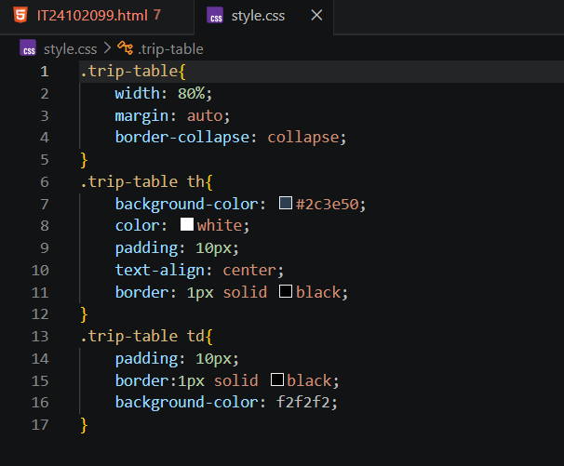
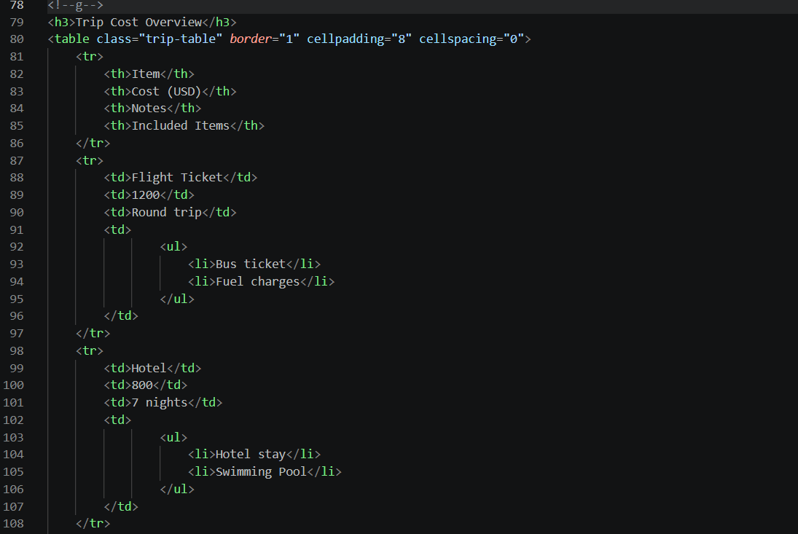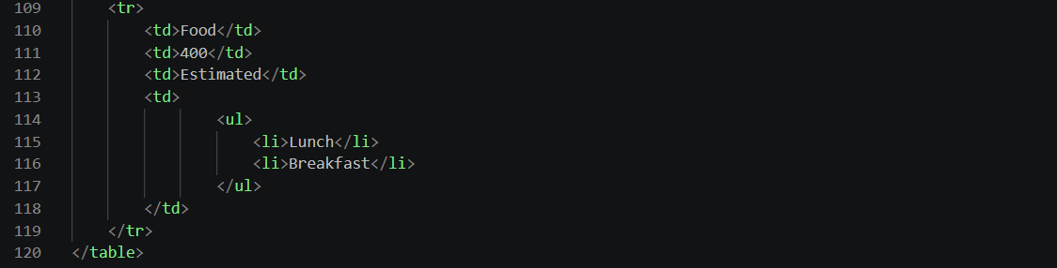

Link external CSS
<link rel="stylesheet" href="style.css">
    - rel="stylesheet" says this file contains styles
    - href="style.css" gives the file path
Table class
<table class="trip-table">
    - this gives the table a class name
    - CSS can now target this table
Header row class
<tr class="header-row">
- applies special style to header row
<tr class="data-row">
Data row class
- applies another style to normal rows
.trip-table {
width: 80%;
border-collapse: collapse;
margin: 20px auto;
text-align: left;
}

    - .trip-table means class selector
    - width: 80% makes table wide but not full screen
    - border-collapse: collapse; merges borders neatly
    - margin: 20px auto; centers the table
    - text-align: left; aligns content left
.trip-table th,
.trip-table td {
border: 1px solid #333;
padding: 10px;
}

    - adds borders to cells
    - adds spacing inside cells

.header-row {
background-color: #4CAF50;
color: white;
}

    - green background for heading row
    - white text for better contrast
.data-row {
background-color: #f2f2f2;
}

    - light gray background for normal rows

About fieldset and legend
<fieldset> groups related form controls together.
<legend> gives a title to that group.
Why do we use fieldset and legend in forms?
We use them to group related inputs and give that group a clear title, which improves readability and form structure.( Because forms become more organized and easier to understand.)

Common Errors + Fixes
1. Image not showing
Cause: wrong file path or image not inside images folder
Fix: check folder name
- check file name spelling
- make sure this is correct: src="./images/travel2.jpg"
2. CSS file not working
Cause: wrong path in <link> or wrong file name
Fix: <link rel="stylesheet" href="style.css">

3. Class styling not applying
Cause: class name mismatch
Fix:
ul.nav li {
display: inline;
}

4. Navigation bar still vertical
Cause: forgot display: inline;
Fix:
ul.nav {
list-style-type: none;
}
5. Bullets still visible
Cause: forgot list-style-type: none;

Why do we use lists for navigation bars : We use lists because a navigation menu is basically a group of links. Using a list gives proper structure, and CSS can then change the list into a horizontal menu bar.
Why are CSS classes useful : CSS classes help us apply the same style to multiple elements. They make the code easier to manage and reuse.
What tag is used to link external CSS : <link>
What HTML tag is commonly used for a navigation bar structure:<ul> with <li> and <a>
list-style-type: none; It removes list bullets.
display: inline; It makes items appear side by side.
border-collapse: collapse; It makes table borders look neat by merging them.
Id : id is usually for one unique element
Class : . class can be reused on multiple elements.

Full code
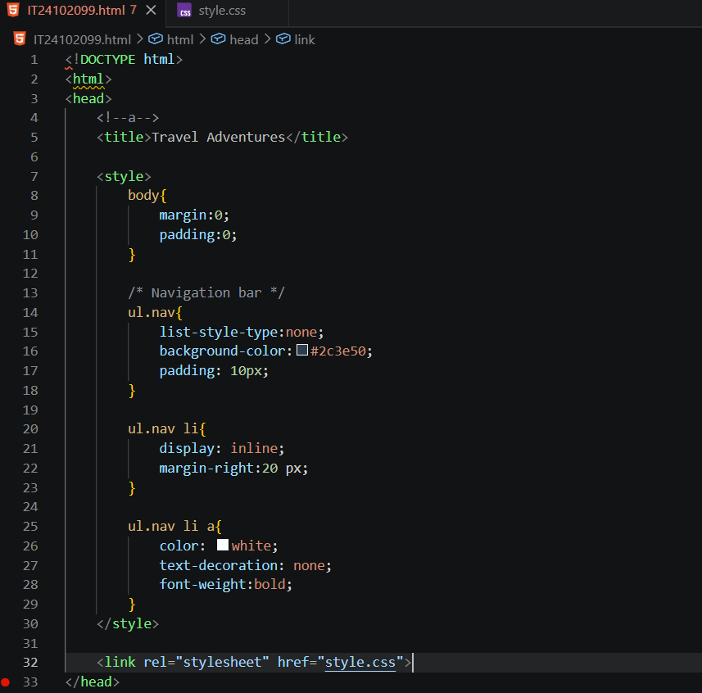

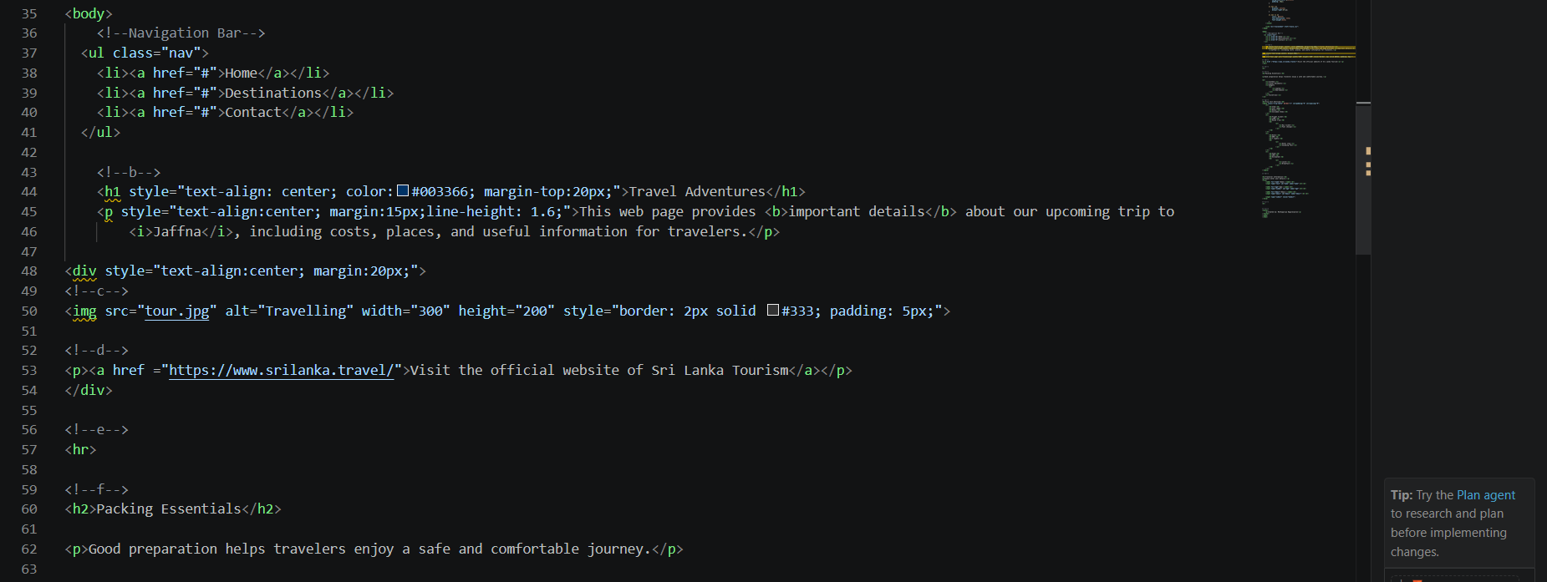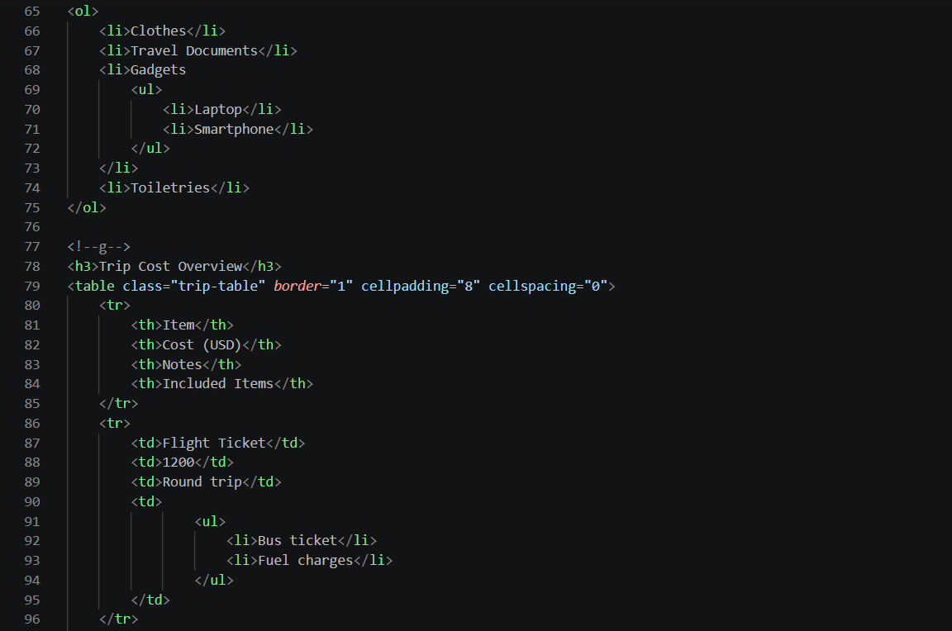
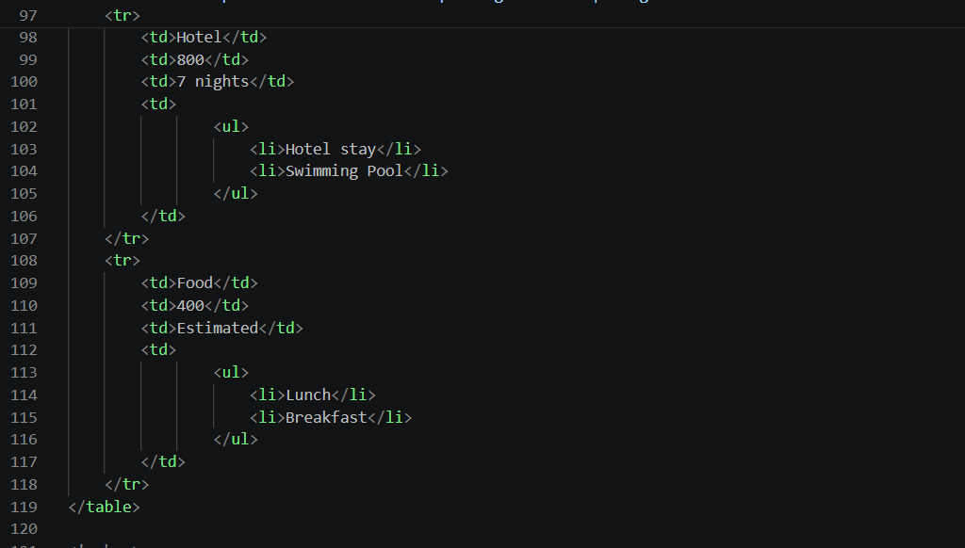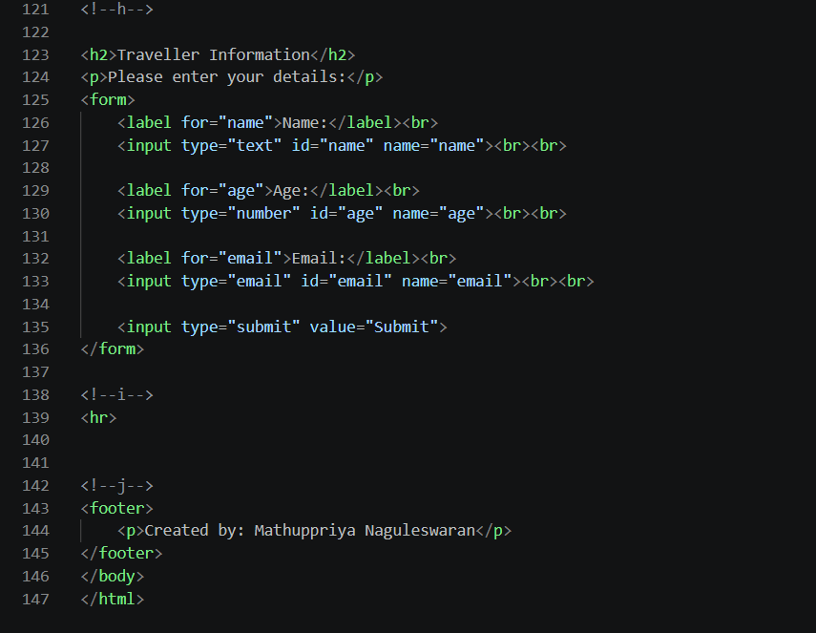
File structure and external css file.
